Date: 7th July 2025

Dear students,

Thank you for choosing Art as one of your GCSE subjects.

My name is Kamar (she, her) and I’m the Head of Art at d’Overbroecks, as well as the 1-year GCSE Art teacher.

The GCSE Art is an exciting, but also demanding course, aimed at those who are passionate about art and making. Students signing up for the 1-year GCSE Art course should have recent experience and a foundation in art to enrol onto the course. Please could you send a small portfolio of work to kamar.finn@doverbroecks.com either as a PowerPoint slideshow or PDF, sharing 10 images of your best work.

GCSE Art and Design Coursework Portfolio Brief
This first project will run from July to January and will make up 60% of your total mark. Carrying out photographic research is a really important element of your project, as it serves as source material for development of later work. I’d like you to base your photographic research on where you are going to spend your summer, ideally your own country, so that we have a real reflection of different cultures when we meet in September. You will need to have DIRECT access to taking these photos – not downloaded from the internet.

Let me introduce the theme, list some options and also tell you a bit about some of the themes already chosen by students going into year 11 as an example.

As soon as you have an idea or two, email me directly on kamar.finn@doverbroecks.com and I can help suggest relevant photoshoots, and then off we go.

Good Luck, Kamar
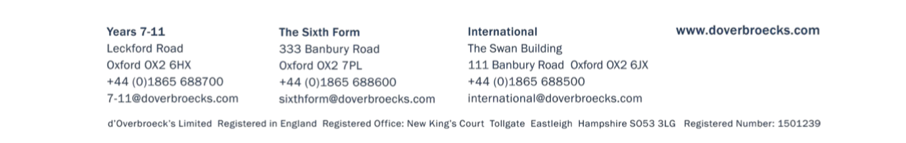

Theme: Wounded landscapes

Wounded Landscapes is about processes. Processes of scarring, rejection, making and breaking, destruction, deterioration and crumbling. Think about how this can relate to your own country, culture or family story. This can be taken in many different directions, such as more personal, political, social, environmental or metaphorical.

The title is for you to interpret in relation to your country of origin. For example, a Romanian student last year looked at a gypsy village (which she then visited twice) as a part of her culture which is often misunderstood and disregarded; another student, from Albania, looked at the dome bunkers, leftovers from the cold war, still found all over the countryside in Albania, like ‘wounds’ in the landscape; a third focused on downtown Hong Kong and the run-down streets; a forth focused on an old derelict building in Moscow, and the list goes on.

Some options for directions, feel free to add more:
- Destroyed landscapes – war, flooding, fires, drought, earthquakes, storms and winds
- Derelict spaces – abandoned, derelict houses, industrial, domestic, telling stories of
the past
- Time and age – signs of crumbling, cracking, staining, peeling on walls, doors.
- Social based – homelessness, poverty, run down neighbourhoods, refugees,
immigration, illness, etc.
- Reflecting on culture – places where old buildings are torn down to make space for new, old vs. new, old traditions replaced by new ones, old architecture replaced by new ones.
- Pollution and the environment – waste, rubbish as part of our culture, plastic bags
decorating the trees and becoming part of nature, rubbish in the streets, landfills
- Politics – See example Ai Wei Wei and Piotr Pawlenski responding to politics through art, making social statements
- Family homes – family remains in the attic, run down grandparents houses, old
villages you have a connection with.

